SIMULATION AND ANALYSIS SETUP
SIMULATION
CURRENT SIMULATION
Experiment name | comm_protect_llin_CMOnly_EIRcat4_nkwanta_south
Purpose | Evaluate the direct and indirect effects of LLINs across transmission intensities
Starting point | - Ghana district (Nkwanta_south)  - Demography  - Vector species  - Health system access  - seasonality
Population size | 10000
EIR categories | 2, 4, 8, 16, 24, 32, 48, 60, 80, 100
Seed | 10
Cohorts | LLIN users and non-users
LLIN Type | IG2  - (most countries have moved to using dual active nets)  - IG2 provided more community protection compared to the other next-gen nets
FINAL SIMULATION SETUP
Experiment name | ComProt_newllinparam2_NS
Purpose | Evaluate the direct and indirect effects of LLINs across transmission intensities
Starting point | - Demography – similar to GHA  - Health system access – 40% constant  - Seasonality – perennial with a peak in October
Population size | 50000
EIR categories | Used EIR: seq(1, 20, 0.5), 24, 32, 48, 60, 80, 100  Low = EIR <= 2  Moderate = EIR >2 – 8  High = EIR > 8
Coverage levels | 10, 20, 30, 40, 50, 60, 70, 80  Added granularity to usage levels and exclude 90%
Seeds | 10
Cohorts | LLIN users and non-users
Interventions | - added CM (40%) throughout: 2000-2031  - Introduced LLIN in 2023
LLIN Type | IG2 net characteristics - new parameterization  Efficacy: CDV ETH: Assenga CI (assuming no insecticidal decay)  - deterrency value = 0.45  - preprandialKillingEffect value = 0.64  - postprandialKillingEffect value = 0.74  Half-life = 2.4 (estimated using usage data from Mosha et al)  Kappa = 2.4 (assuming early retention of nets)  Vector species: assume  - gambiae (60%) – SR: 0.114  - funestus (30%) – SR: 0.235  - arabiensis (10%) – SR: 0.049  assume SR are same as defaults in the new param template - TZ
FINAL SIMULATION SETUP (100K POPSIZE)
Experiment name | ComProt_newllinparam2_NS
Purpose | Evaluate the direct and indirect effects of LLINs across transmission intensities
Starting point | - Demography – similar to GHA  - Health system access – 40% constant  - Seasonality – perennial with a peak in October
Population size | 100000 (same size as in Unwin et al.)
EIR categories | Used EIR: seq(1, 20, 0.5), 24, 32, 48, 60, 80, 100  Low PfPR = EIR <= 2  Moderate PfPR = EIR: 2.5 – 8  High PfPR = EIR > 8
Coverage levels | 10, 20, 30, 40, 50, 60, 70, 80  Added granularity to usage levels and exclude 90%
Seeds | 10
Cohorts | LLIN users and non-users
Interventions | - Assume 40% CM throughout: 2000-2031  - Introduced LLIN in 2023
LLIN Type | IG2 net characteristics - new parameterization  Efficacy: CDV ETH: Assenga CI (assuming no insecticidal decay)  - deterrency value = 0.45  - preprandialKillingEffect value = 0.64  - postprandialKillingEffect value = 0.74  Half-life = 2.1 (Ngufor et al)  Kappa = 1.4 (1.35 in Luke’s thesis)  Vector species: assume  - gambiae (60%) – SR: 0.114  - funestus (30%) – SR: 0.235  - arabiensis (10%) – SR: 0.049  assume SR are same as defaults in the new param template - TZ

ANALYSIS
WHO categories of transmission intensity from the WHO guidelines for malaria, August 2025: (MAGICapp - Making GRADE the Irresistible Choice - Guidelines and Recommendations)
“The following categories of transmission intensity are indicative and meant to provide an adaptable framework in which each country can conduct a stratification exercise to classify geographical units according to local malaria transmission”
Very low - prevalence of P. falciparum malaria > 0 but < 1%
Low - prevalence of P. falciparum of 1–10%
Moderate - P. falciparum malaria of 10–35%
High - P. falciparum prevalence rate of ≥35%

Sensitivity analysis
Assess robustness of the results by repeating the simulations under an alternative LLIN parameterization representing faster net attrition and reduced insecticidal efficacy, then compared key outcomes with the base-case parameterization.
Parameter | Base-case Value | Sensitivity Value
Physical durability:  - half-life  - kappa | 2.4 years  2.4 | 1.7 years (reduced)  1.35 (reduced)
Efficacy:  - detterency  - pre-prandial killing effect  - post-prandial killing effect | 0.45  0.64  0.74 | 0.65 (increased by 0.2)  0.44 (reduced by 0.2)  0.54 (reduced by 0.2)
PfPR categories:  - Low  - Moderate  - High | 0-9-10%  13-34%  36-46% | 4%  24%  46%

Outcomes to consider
Total number protected from infection by user status
Coverage at which Equity ratio between users and non-users = 1
These findings demonstrate that the usage levels required for non-users to benefit maximally from community protection are strongly transmission dependent. The difference in prevalence reduction between users and non-users declined across transmission intensities as usage increased, diminishing at high usage. However, in high transmission settings a substantial difference was still observed at high usage (Figure 4B).
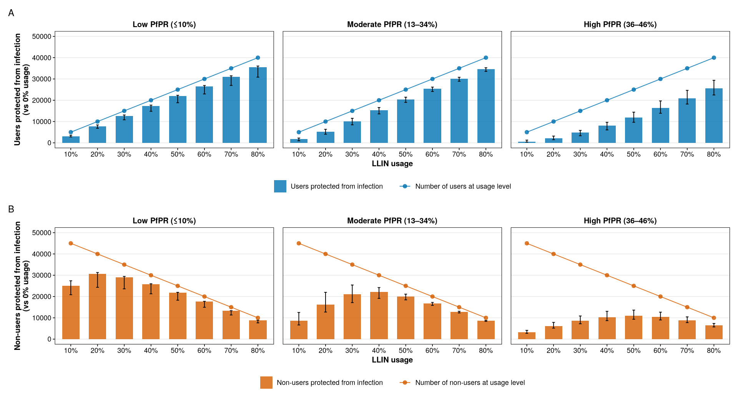
Figure 4: Number of LLIN users and non-users protected from infection. (A) is the relationship between LLIN usage and prevalence reduction among LLIN users and non-users shown for transmission intensity levels. Horizontal dashed lines indicate 25% and 50% prevalence reduction thresholds, and vertical dotted lines indicate the LLIN usage required to achieve these thresholds. Required LLIN usage increases with transmission intensity, reaching near-universal coverage levels at high EIR levels. Red represents non-users and blue represents users. (B) shows the difference in prevalence reduction between users and non-users (gaps between red and blue curves in (A)).

